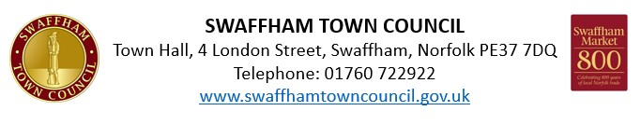
Christmas Light Switch On & Christmas Market
Sunday 30 November 2025
Artisan Fayre
Oasis Centre Stall Application

Please complete in block capitals

NAME:

ADDRESS:

TEL NO:

EMAIL:

PRODUCT DESCRIPTION:

WEBSITE AND SOCIAL MEDIA PLATFORMS:
For promotion purposes

Booking Form

Description | Price | Requirement
Stall | £0
Total | £

A confirmation of your booking will be included in an invoice, which will be sent to the email provided.

Important Information

- Public Liability Insurance is required for all bookings. Applications will not be accepted without appropriate coverage.
- Access & Setup: Times will be confirmed.

Marketing Permission
I consent to the Town Council promoting my stall: Yes / No (Please circle)
Date: __________________________
Signature: __________________________
Return form to: comms@swaffhamtowncouncil.gov.uk

