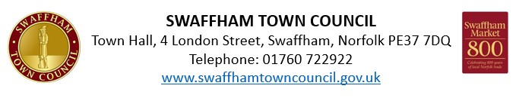Christmas Light Switch On & Christmas Market
Sunday 30 November 2025
Outdoor Stall Application

Please complete in block capitals

NAME:

ADDRESS:

TEL NO:

EMAIL:

PRODUCT DESCRIPTION:

WEBSITE AND SOCIAL MEDIA PLATFORMS:
For promotion purposes

Booking Form

Description | Price | Requirement
Stall (own gazebo) - 10ft x 10ft | £20
Food Stall | £40
Extra stall size (£1 per additional foot) | £1 per foot | Please specify ______ x ______ ft
Gazebo Hire (includes one table and two chairs) | £15
Total Cost: | £ _________

A confirmation of your booking will be included in an invoice, which will be sent to the email provided.

Important Information

- Public Liability Insurance is required for all bookings. Applications will not be accepted without appropriate coverage.
- Food stalls will be assessed using the Food Standards Agency website. A hygiene rating below 5 will not be accepted.
- Access & Setup: The car park will open for stallholders from 8.00 AM. All stalls must be set up, and vehicles removed from the market area by 9.30 AM.

Marketing Permission
I consent to the Town Council promoting my stall: Yes / No (Please circle)
Date: __________________________
Signature: __________________________
Return form to: comms@swaffhamtowncouncil.gov.uk

